Individual Project

-Ideation Document-

Git repository link: https://git.fhict.nl/I508548/rizz-air.git

**Project description:**

My project for this semester is going to be about an airline company that is trying to have a way of selling tickets on their available flights. The app will be called Rizz Air and the target audience is adults that want to fly high class from Romanian airports. We will provide from Business class level flights to travelling in utter luxury in private jets or helicopters. The project is going to be divided into the Windows Forms App in which the admin and to some extend the employees will have access to, and a Web App, where the users can book their desired flights.

**Users hierarchy:**

1. Admin

The admin is able to see statistics about their business such as revenue or flights available. Moreover, they are able to manage the users and the employees. Furthermore, they are able to manage the shifts of the employees. All of the functionalities are possible using the Windows Forms App.

1. Employee

The employee are responsible for managing the flights and the tickets available for them. They are also responsible for the purchase requests from the users for the ticket that they chose. Employees will be able to see their schedule and to do all the functionalities shown above using the Windows Forms App.

1. User

Users, via the Web App website, will be able to see all the tickets available for purchase. Creating an account is mandatory to access the website and they can change any information at any point in time after the login process has been completed. The purchases would be able to be done via a bank account or using the in-app wallet.

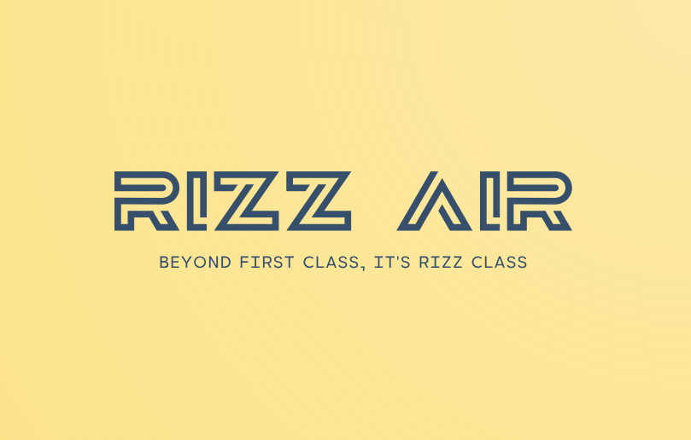**Logo:**

**Site Map:**

**Wireframe:**